Development Log – OCR A Level CW

* A log of the development of my coursework for an A-Level project (a lifeguard rota creation tool), here I will document each stage of the process and justify my decisions and actions throughout.

# Stage 1 – First Class

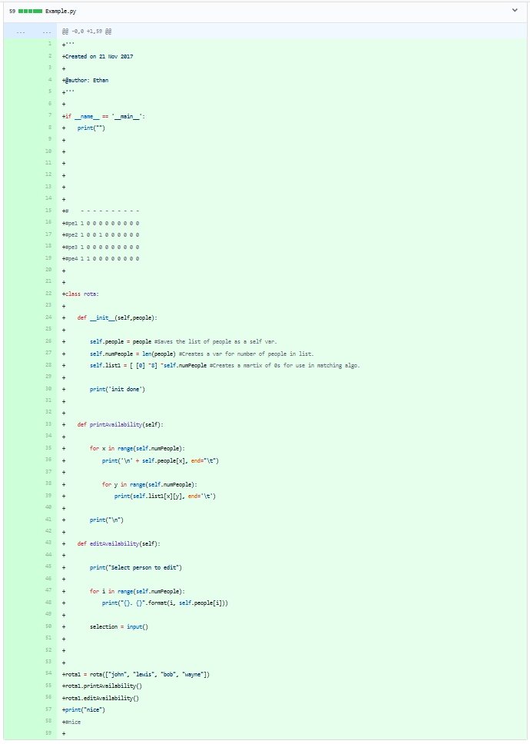

The first stage of my development was the creation of the main python file, and along with it the initial class for testing the ‘availability’ part of the program. The idea I had here was to make a matrix of the availability of the staff members, in order for a future matching algorithm to match each person to a position for each half hour. This can be seen from the comment early in the code that shows my idea for the matrix.

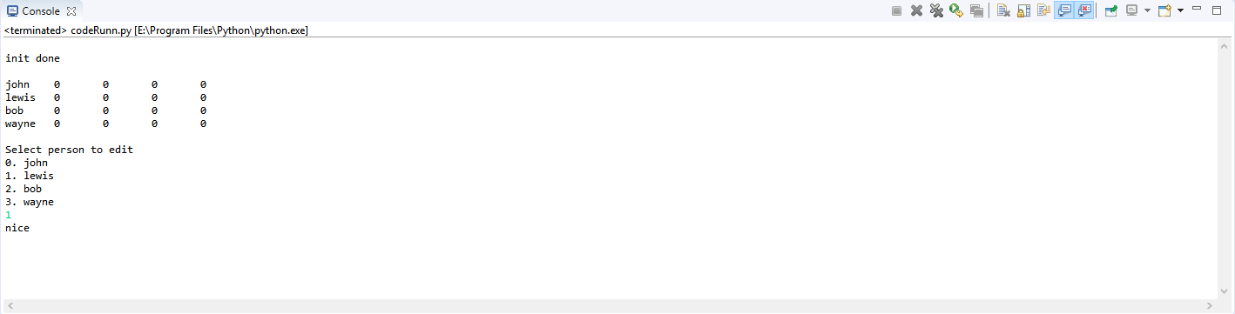The class in this stage is very basic, with only an initialization, print and edit function (that isn’t yet working), all it does is create a matrix of length depending on how many people’s names are parsed to the class. Its output below:

This shows the matrix being printed along with the names of staff being parsed to the class when created, and also shows the beginnings of the edit function. Please ignore the “nice” that is printed as this is only for testing that each class function ran properly. The input also doesn’t do anything at this stage.

# Stage 2 – Changing to A Dictionary

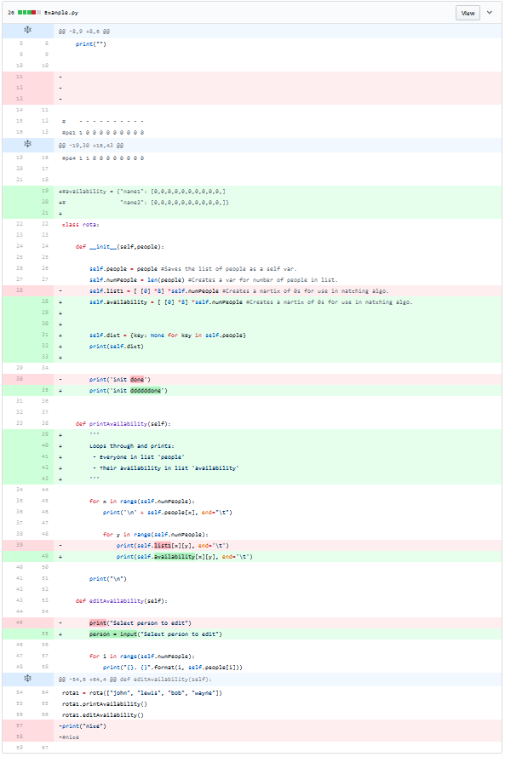

After thinking about the issue at hand, I decided that now I have a base to work from I would start changing and adding to it to make it easier to work with. I am still focusing on the availability part of the program. This commit changes several comments too, as seen in the screenshot; I will not go into detail about these. I also changed the name of a couple variables, and made the input actually save to a variable rather than do nothing as before.

The main changes to see here is the introduction of a dictionary rather than a list for the matrix, as I can store the names of the staff members as well as their availability in one data structure; this allows easier manipulation and access of the data. I used dictionary comprehension to create a dictionary with each member of staff as the key and ‘None’ as the values, and soon the ‘None’ will be replaced with the list of availability for the individual used in the key.

Output of the new dictionary creation code is below:

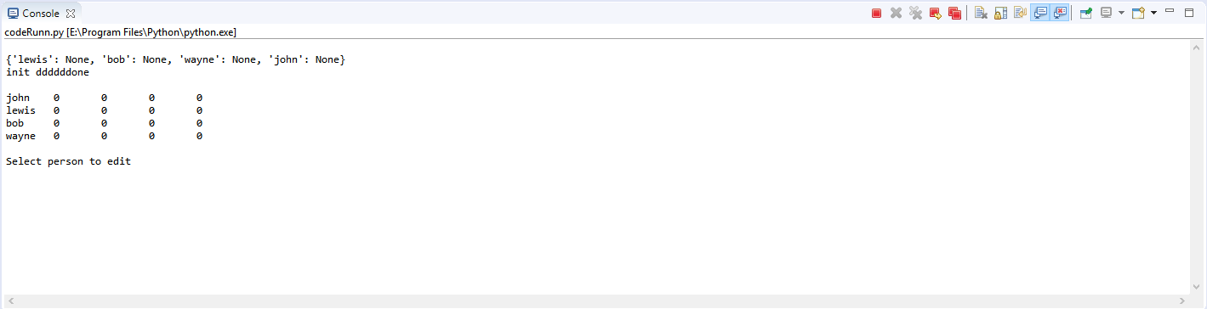

As shown by the screenshot, the new dictionary is created successfully in an efficient manner as only one line is used to generate it.